MACH4METAL

metalworking machinery
Transito 21
6909 DA BABBERICH Netherlands
Tel. +31 (0)316-247123
Fax: +31 (0)316-247956
info@mach4metal.com
www.mach4metal.com

Bank No : 66.52.13.883
IBAN : NL33 INGB 0665 2138 83
BIC : INGBNL2A

Stolting 4 roll plate bender 2500x40
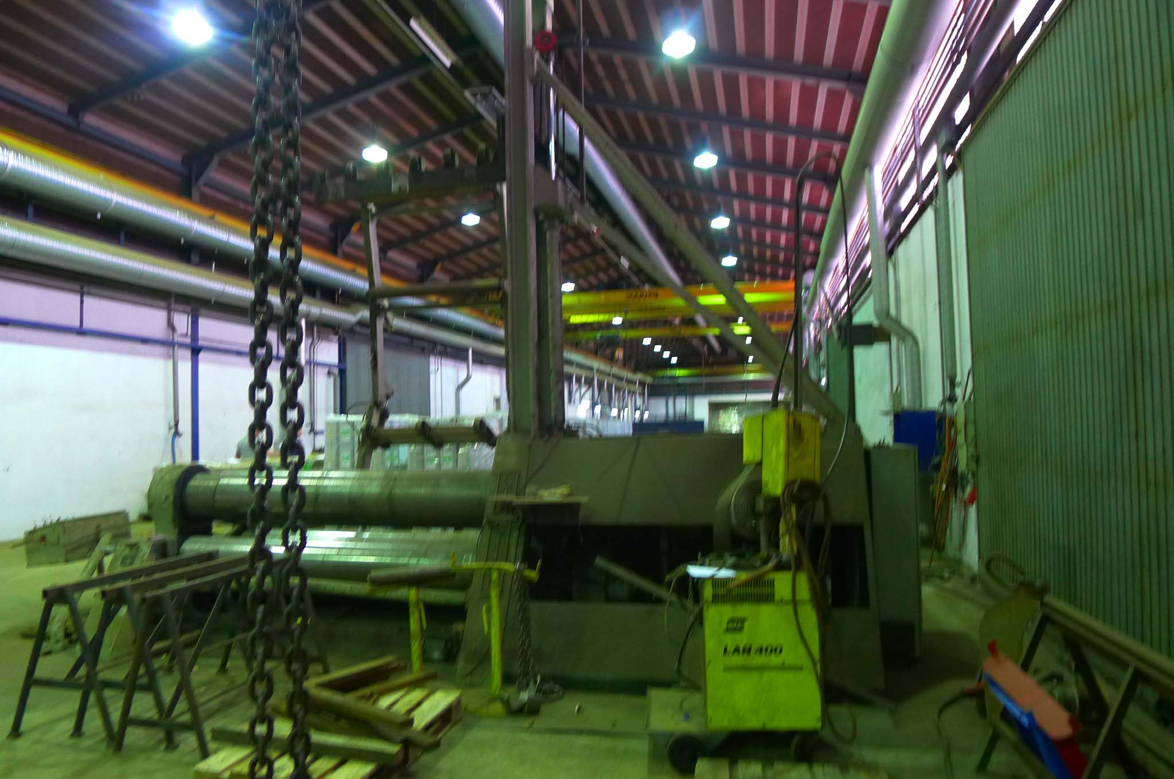
- Make : STOLTING Germany
- Typ : VB 2500 / 40
- Serial : M 1441
- Age : 1997 delivery

- bending length : 2500 mm
Bending capacity
- Ø 2500 : 2500 x 45
- Ø 1500 : 2500 x 40
Pre Bending capacity
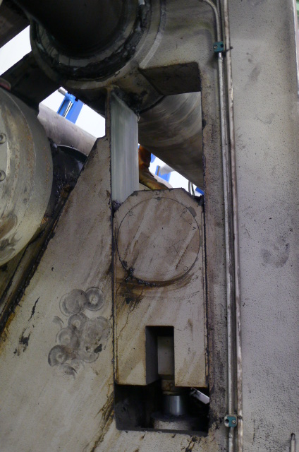
- Ø 2500 : 2500 x 35
- Ø 1500 : 2500 x 32

- Top roll Ø : 480
- Lower roll Ø : 480
- Side roll Ø : 390

- Working speed : 0 – 6 M /min.
- Adj. side & lower roll : 200 mm/min.

- Dimensions
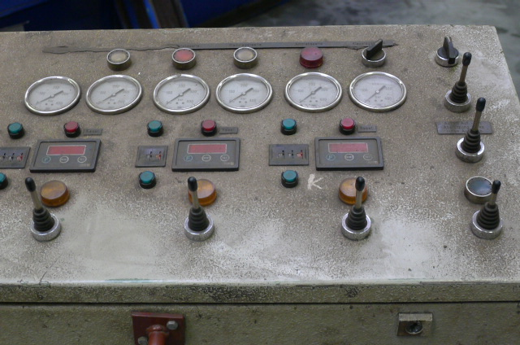
- Length : 7.130
- Width : 2.700
- Height : 2.530
- Weight : 32 Ton
- Power : 37 kW

- Conical bending attachment
- Hardened rolls
- Digital readout position rolls
- Central lubrication
- Top ( 5000 mm) & side support

Please Note: The above information has been obtained to the best of our ability and belief from, and from the manufacturers where possible. It is given in good faith, but its accuracy can not be guaranteed. Accordingly, it will not form a representation or constitute contractual terms. We advise you to check any vital details!

